A REFLECTION FOR HOLY WEEK IN LOCKDOWN

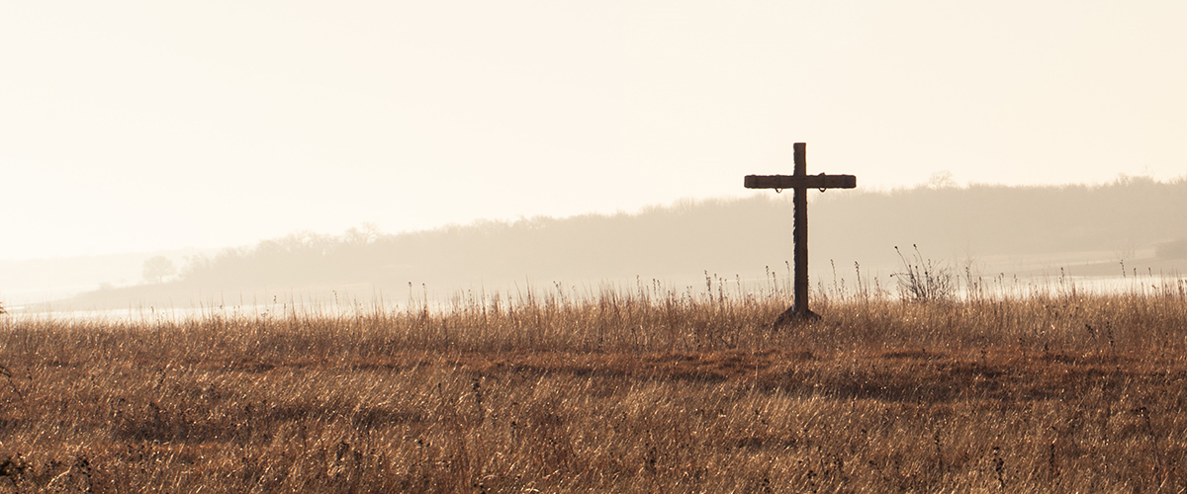

“Wait on God alone in stillness, O my soul;
for in him is my hope.
He alone is my rock and my salvation,
my stronghold, so that I shall not be shaken.
In God is my strength and my glory;
God is my strong rock; in him is my refuge.
Put your trust in him always, my people;
pour out your hearts before him, for God is our refuge.”
(Psalm 62:5-8)

This will be a Holy Week like no other.
Almost all of us have experienced an unprecedented disruption of our normal routines. Meeting friends; taking a bus into town; spending time with our families; visiting the shops; going to Church: all these things are either ‘on hold’ or radically different to what they were only a few weeks ago.
We all know that big changes tend to be a source of big anxiety, and many people are feeling that anxiety now. Combine this disruption-induced anxiety with the constant worry about whether we or those we love are going to fall victim to the virus, or be able to get the food and medical support we need, and you have a recipe for enormous levels of stress.
And there is another kind of anxiety I am beginning to notice, in those I talk to and in myself. We have more time on our hands than we are used to having. How should we fill that time? How should we continue to be productive? How should we as Church best reach out to all those most in need right now?
Personally, I have found this anxiety often taking the form of constantly wondering about whether to start a new initiative: something to support the community, or a new way to keep in touch with those in the church: shouldn’t we be Zooming or Skyping or Live-streaming services? What are other churches doing? Shouldn’t we be doing the same…?
Now, none of these things is bad. I’m delighted that many are making use of the huge range of resources available. But, rather than allowing ourselves to get too caught up in the need always to be doing things, it strikes me that one of the gifts each of us is being offered in the midst of this crisis is the opportunity to learn simply to be.
Our lives are so busy, so full of activity. And our society tends to value people by what they do. (The first question we tend to ask when we meet someone for the first time is, “What do you do?”) One of the most basic things the Christian faith affirms about all of us is that our value comes simply from who we are – beloved children of God, created in His image.
It might not feel much like it, but most of us do have some time available right now. We have the opportunity to enjoy simply being: in our spiritual practices, as in our daily lives.
Of course, that is easier said than done! But how might we go about learning to be with God this Holy Week?
The following story seemed to me to offer a glimpse of a way. (I’m grateful to Gordon Gething for reminding me of it.)

Metropolitan Anthony Bloom was a monk in the Russian Orthodox Church, and a well-know writer and broadcaster on prayer and the spiritual life. One day, a lady in his congregation went to see him. Although she had prayed faithfully all her life, she explained, she had never experienced any real sense that God was present in her life. Why were her prayers not answered? Did God not love her?
Metropolitan Anthony offered her this advice: “Next time you come to a prayer time, don’t kneel or say any prayers or psalms or liturgy. Just sit in your favourite armchair by the fire, and relax.”
The woman followed his advice, and simply relaxed by the fire. She was a very committed and busy Christian, and had never allowed herself this kind of ‘luxury’ before. As she sat, she thought, “What a lovely room!” She looked around at the ornaments, furniture and pictures in the room. Each of them told a story: of friendship, of love, of family. She felt warmed by these memories, and by the fire. She was delighted by the view from her window. Gratitude for all the richness in her life started to bubble up. She made no effort to pray, but suddenly realised it was as if God was speaking to her in words of comfort and love, and every aspect of her life – the memories, her surroundings, the physical contents of her room – were mediating those words.
She understood that this was what was behind Anthony’s advice. Her constant and well-intentioned busyness had carried over into her relationship with God. She had talked to Him, praised Him, asked Him for things – but had never simply listened to Him, never stopped for long enough just to be, and to allow her life to be God’s word to her.

Many of you have already mentioned good things which have come from this dreadful crisis. If we can take the time this Holy Week to stop, listen, reflect, and simply be, we may discover we have been given a precious gift indeed.

A simple prayer:
Lord, you are in this place.
You are with me now.
Help me to relax in your presence,
to rest in your heart,
to reflect on your love,
to listen for your voice,
and simply to delight in being who I am - your much-loved child.
Amen.

I began this reflection with some beautiful words from Psalm 62. Here is a link to one of my favourite songs by John Michael Talbot, based on this Psalm:

https://www.worshiptogether.com/songs/only-in-god-psalm-62-john-michael-talbot/

Adapted from a story by Mark Barrett OSB in The Little Book of Lent, pp.56-58.

